**Ideation Phase**

**Define the Problem Statements**

|  |  |
| --- | --- |
| Date | 29 April 2023 |
| Team ID | NM2023TMIDO6343 |
| Project Name | Traffic Intelligence: Advanced Traffic Volume Estimation With Machine Learning |
| Maximum Marks | 2 Marks |

**Customer Problem Statement Template:**

Traffic problem is one of the major problem now a days, In the increase in no of vehicles and non –usage of public transport leading to traffic related issues, Making a eye on count of traffic at each level enables the government  to take the further decisions such as building new roads, increasing infrastructure,developing mutli-channel connectivity . Customer are getting frustrated due to heavy traffic and they getting late for there works and they getting angry due to violation off traffic rules by the other citizens.

|  |  |
| --- | --- |
|  |  |

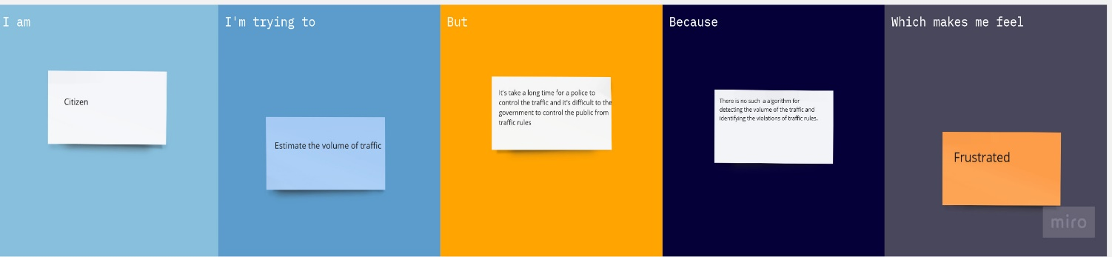

|  |  |  |  |  |  |
| --- | --- | --- | --- | --- | --- |
| **Problem Statement (PS)** | **I am (Citizen)** | **I’m trying to** | **But** | **Because** | **Which makes me feel** |
| PS-1 | Citizen | Estimate the volume of traffic | It's take a long time for a police to control the traffic and it's difficult to the government to control the public to follow traffic rules | There is no such a algorithm for detecting the volume of the traffic and identifying the violations of traffic rules. | Frustrated |
| PS-2 | Citizen | Developing the Algorithm for traffic volume and identifying the violation of traffic rules using ML | Arranging the algorithm developed system in the heavy traffic places for better estimation of volume of a traffic. | This algorithm detect the traffic rules violations | Frustrated |